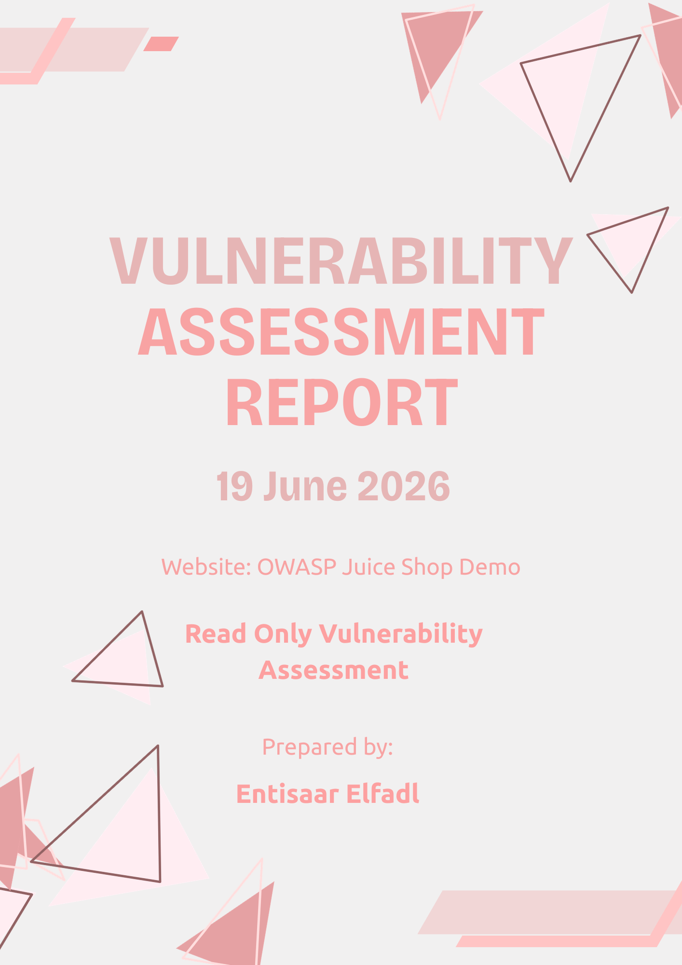
Table of Contents
Executive Summary 3
Purpose of Assessment 3
Scope 3
Methodology 4
Tools Used 4
Assessment Findings 5
Positive Security Controls 7
Risk Summary 7
Recommendations 7
Conclusion 7
Appendix 8

Executive Summary

Purpose of Assessment
The purpose of this assessment was to evaluate the security posture of the OWASP Juice Shop demo application using passive, non-intrusive techniques. The assessment focused on identifying publicly visible security weaknesses without attempting to exploit any vulnerabilities.
The assessment was conducted using network scanning, HTTP security header analysis, browser developer tools, and HTTPS configuration review.
Overall, the website demonstrated several positive security controls, including the use of HTTPS and certain browser security headers. However, several missing security headers and exposed network services were identified that could increase the application's attack surface if left unaddressed.

Scope
Target Website
https://demo.owasp-juice.shop/#/
Assessment Type
Read Only Vulnerability Assessment
Included Activities:
- Network port scanning
- HTTP security header analysis
- Browser response header inspection
- SSL/TLS configuration review
Excluded Activities:
- Exploitation
- Brute force attacks
- Authentication bypass
- Denial of Service attacks
- Any intrusive testing

Methodology
This assessment followed a structured process that was inspired by the guidelines
- Selected a publicly accessible web application suitable for ethical security assessment.
- Performed a network scan using Nmap to identify publicly exposed services.
- Inspected HTTP response headers using browser developer tools.
- Analysed implemented and missing security headers using SecurityHeaders.com.
- Documented findings, classified risks, and developed remediation recommendations.

Tools Used
Tool | Purpose
Nmap | Network port scanning
SecurityHeaders.com | HTTP security header analysis
Browser Developer Tools | Response header inspection
Microsoft Word | Report design

Assessment Findings
1. Exposed Network Services  Risk Level:  Medium  Description:  Scan identified several publicly accessible services running on the target server.  Open Ports Detected:  - FTP (21)  - HTTP (80)  - HTTPS (443)  - HTTP Proxy (8080)  - Port(1723 was filtered)  Impact:  Every publicly accessible service increases the organization's attack surface. While not all exposed services represent vulnerabilities, unnecessary services may provide attackers with additional opportunities for reconnaissance or exploitation if they become misconfigured or outdated.  Evidence:  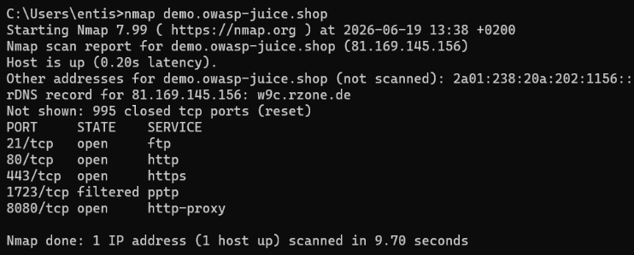  Recommendation:  - Disable services that are not required.  - Restrict access to administrative services.  - Perform regular reviews of exposed network services. | 2. Missing Content Security Policy Header  Risk Level:  Medium  Description:  Scan assessment identified that the website does not implement a Content Security Policy (CSP).  A CSP restricts which sources of content a browser is allowed to load, helping to mitigate attacks such as Cross Site Scripting (XSS).  Impact:  Without a Content Security Policy, attackers may have an easier opportunity to execute malicious scripts if an injection vulnerability exists elsewhere in the application..  Evidence:  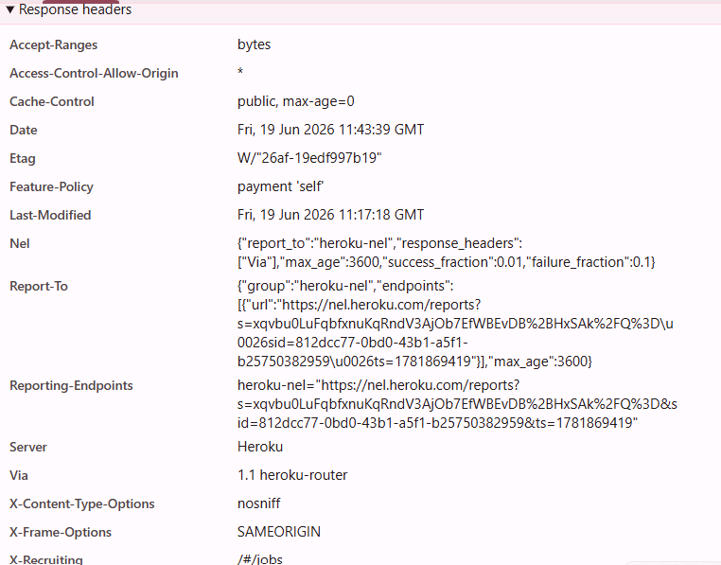  Recommendation:  Implement a Content Security Policy that explicitly defines trusted sources for scripts, stylesheets, images, and other resources.
3. Missing Referrer Policy Header  Risk Level:  Low  Description:  The Referrer Policy header was missing. This header controls how much information browsers send when users follow links to other websites.  Impact:  Sensitive information contained in URLs could unintentionally be shared with third party websites.  Evidence:    Recommendation:  Configure an appropriate Referrer Policy, such as strict-origin-when-cross-origin. | 4. Missing Permissions Policy Header  Risk Level:  Low  Description:  The Referrer Policy header was missing. This header controls access to browser features like such as camera, microphone, and geolocation.  Impact:  Missing restrictions may allow unnecessary browser capabilities to remain available if future application functionality is introduced.  Evidence:  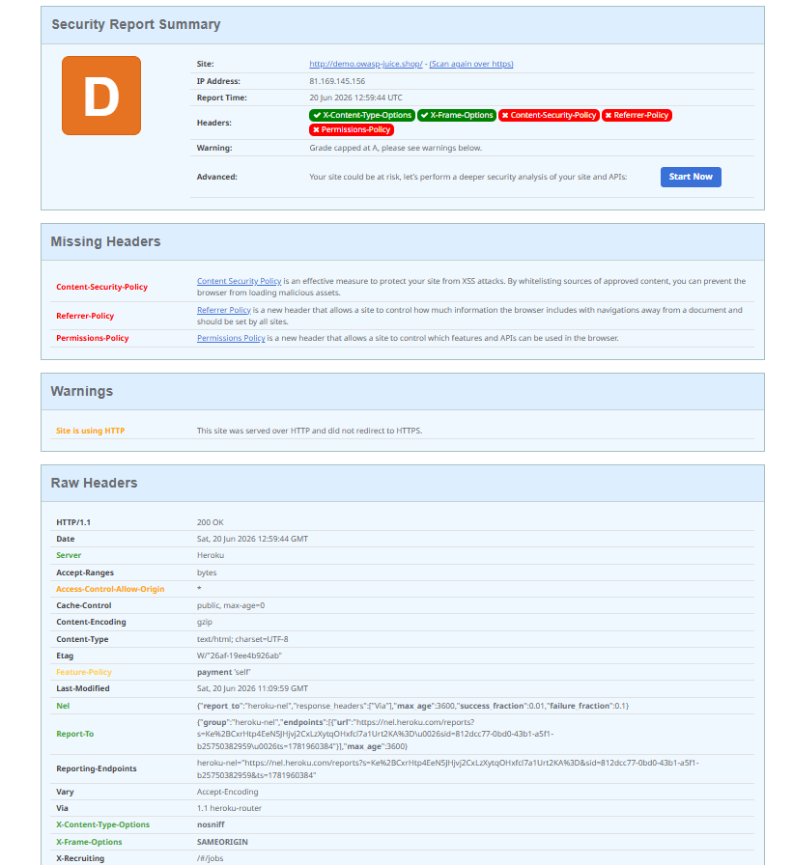  Recommendation:  Implement a Permissions Policy that disables browser features not required by the application.

5. Website Accessible Over HTTP

Risk Level:
Medium

Description:
The assessment indicated that the website could be accessed over HTTP. Although HTTPS is available, HTTP connections increase the possibility of unencrypted communication if users access the insecure version.

Impact:
Users may unknowingly access the unencrypted version of the site, increasing the risk of interception during transmission.

Evidence:


Recommendation:
Redirect all HTTP traffic automatically to HTTPS and enable HTTP Strict Transport Security (HSTS).

Positive Security Controls
Not all the findings were negative as the scanned results also showed several good security practices:
- The security headers that were implemented were X Content Type Options and X Frame Options.
- These headers help protect users against MIME type sniffing and clickjacking attacks.
- HTTPS was successfully configured, allowing encrypted communication between clients and the web application.

Risk Summary
Finding | Risk
Exposed Network Services | Medium
Missing Content Security Policy | Medium
Website Accessible Over HTTP | Medium
Missing Referrer Policy | Low
Missing Permissions Policy | Low

Recommendations
To improve the application’s security posture, I would recommend:
- Remove or restrict unnecessary publicly exposed services.
- Implement a Content Security Policy.
- Configure a Referrer Policy.
- Configure a Permissions Policy.
- Redirect all HTTP requests to HTTPS.
- Continue performing regular vulnerability assessments.
- Keep server software updated.
- Review security configurations periodically.

Conclusion
A passive vulnerability assessment was conducted on the OWASP Juice Shop demo application using industry standard tools and ethical assessment techniques.
The assessment identified several medium and low risk security observations. The most significant findings were the presence of multiple exposed services, missing browser security headers, and the availability of the application over HTTP. As the target website is an intentionally vulnerable training environment, these findings are expected and serve to demonstrate common web application security weaknesses.
Although the application implements certain security controls, including HTTPS support and selected browser security headers, additional hardening measures would further improve its overall security posture.
Implementing the recommended controls would reduce the application's attack surface and strengthen protection against common web-based attacks.

Appendix

Appendix A: Header Scanner scr1
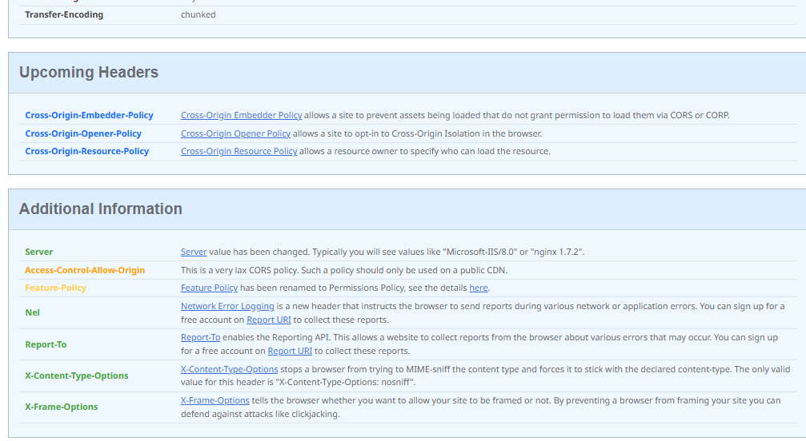
Appendix B: Header Scanner scr2
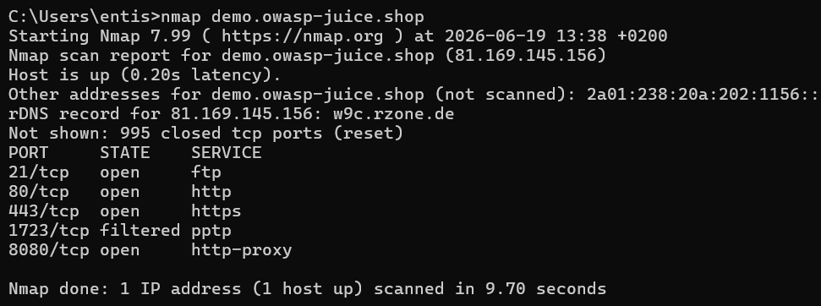
Appendix C: Nmap Network Scan

Appendix D: Security Headers Inspection

